Experiment 2
Aim : LOGINPAGE: All the login deatils
Description – LOGINPAGE: All the login deatils
Description of Tags Used
1. login.html
- <!DOCTYPE html> – Declares that the document uses HTML5.
- <html> – The root element of the HTML document. The lang="en" attribute specifies that the page is in English.
- <head> – Contains information about the webpage that is not directly displayed on the page.
- <meta> – Provides metadata about the webpage. charset="UTF-8" defines the character encoding, while the viewport meta tag makes the page responsive.
- <title> – Specifies the title displayed on the browser tab.
- <body> – Contains all the visible content of the webpage.
- <table> – Creates a table. In this page, it is used to create a bordered box around the login form.
- <tr> – Defines a row inside the table.
- <td> – Defines a cell inside the table row.
- <h1> – Defines the main heading of the page, "Online Book Store Login".
- <form> – Creates a form for accepting and submitting user information.
- <label> – Defines a label for an input field, such as Username and Password.
- <input> – Creates input fields and buttons. It is used for entering the username, password, and submitting the form.
- <br> – Inserts a line break between different elements.
- <a> – Creates a hyperlink. It is used to provide the "Forgot Password" link.
Attributes used in login.html
- action – Specifies the destination page where the form is submitted.
- type="text" – Creates a normal text input field for the username.
- type="password" – Creates a password input field where the entered characters are hidden.
- type="submit" – Creates a button to submit the form.
- id – Gives a unique identification to an element.
- name – Specifies the name of the form field.
- required – Makes it compulsory for the user to enter a value before submitting.
- value – Specifies the text displayed on the submit button.
- for – Connects a <label> with its corresponding input field.
- href – Specifies the destination of the hyperlink.
- target – Specifies where the linked page should open.
- border – Specifies the thickness of the table border.
- bgcolor – Specifies the background color of the table.
- align – Aligns the content or table. In this program, it is used to center the content.

2. forgetpassword.html
- <!DOCTYPE html> – Declares the document as an HTML5 document.
- <html> – Defines the root of the HTML document.
- <head> – Contains metadata and information about the webpage.
- <meta> – Defines metadata such as character encoding and viewport settings.
- <title> – Defines the title displayed on the browser tab.
- <body> – Contains the visible content of the webpage.
- <table> – Creates a table used to organize the forgot-password form.
- <tr> – Defines a row in the table.
- <td> – Defines a cell in the table.
- <h1> – Displays the main heading "Forgot Password".
- <form> – Creates the form used to enter email and OTP details.
- <label> – Defines labels for the Email and OTP input fields.
- <input> – Creates input fields for email, OTP, and the submit button.
- <br> – Inserts line breaks between form elements.
Input types used in forgetpassword.html
- type="email" – Creates a field for entering an email address and provides basic browser validation.
- type="text" – Creates a normal text field for entering the OTP.
- type="submit" – Creates the button used to submit the form.
Common attributes
- id – Uniquely identifies an input element.
- name – Specifies the name of the input field.
- required – Ensures that the field cannot be left empty.
- action – Specifies the page to which the form is submitted.
- for – Associates a label with a particular input field.
- border – Sets the thickness of the table border.
- bgcolor – Sets the background color of the table.
- align – Aligns the content to the center.
Code :-

Top.html
<!DOCTYPE html>
<html>

<body bgcolor="#FFB6A6" width="100%">
<table width="100%">
<tr>
<td>
<img src="media/images/logo/logo.png" alt="logo" height="120">
</td>
<td align="center">
<h1>
G.L BAJAJ INSTITUTE OF TECHNOLOGY AND MANAGEMENT
</h1>
<h2>
Online Book Store
</h2>
</td>
</tr>
</table>
<center>
<a href="home.html"
target="home">HOME</a>&nbsp&nbsp&nbsp&nbsp&nbsp&nbsp&nbsp&nbsp&nbsp&nbsp&nbsp&nbsp&nbsp&nbsp&nbsp&nbsp&nbsp&nbsp&nbsp&nbsp&nbsp&nbsp&nbsp&nbsp&nbsp&nbsp&nbsp&nbsp
<a href="/Experiment02/login.html"
target="home">LOGIN</a>&nbsp&nbsp&nbsp&nbsp&nbsp&nbsp&nbsp&nbsp&nbsp&nbsp&nbsp&nbsp&nbsp&nbsp&nbsp&nbsp&nbsp&nbsp&nbsp&nbsp&nbsp&nbsp&nbsp&nbsp&nbsp&nbsp&nbsp&nbsp
<a href="register.html"
target="">REGISTER</a>&nbsp&nbsp&nbsp&nbsp&nbsp&nbsp&nbsp&nbsp&nbsp&nbsp&nbsp&nbsp&nbsp&nbsp&nbsp&nbsp&nbsp&nbsp&nbsp&nbsp&nbsp&nbsp&nbsp&nbsp&nbsp&nbsp&nbsp&nbsp
<a href="catalogue.html" target="">CATALOGUE</a>
</center>
</body>

</html>

Login.html
<!DOCTYPE html>
<html lang="en">

<head>
<meta charset="UTF-8">
<meta name="viewport" content="width=device-width, initial-scale=1.0">
<title>Login</title>
</head>

<body align="center" bgcolor="#9BCEC1">
<table border="4" align="center" bgcolor="#F4F6F9">
<tr>
<td>
<h1>Online Book Store Login</h1>

<form action="/Experiment01/home.html">
<label for="username">Username : </label>
<input type="text" id="username" name="username" required>
<br><br>

<label for="password">Password:</label>
<input type="password" id="password" name="password" required>
<br><br>

<input type="submit" value="Submit">
</form>

<a href="forgetpassword.html">Forgot Password</a>
</td>
</tr>
</table>
</body>

</html>

Output :-
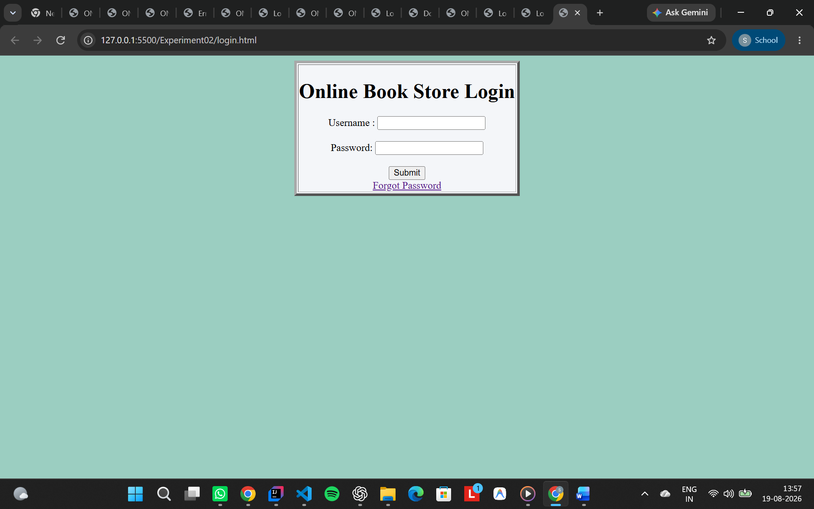

Forgetpassword.html
<!DOCTYPE html>
<html lang="en">

<head>
<meta charset="UTF-8">
<meta name="viewport" content="width=device-width, initial-scale=1.0">
<title>Document</title>
</head>

<body align="center" bgcolor="#9BCEC1">
<table border="4" align="center" bgcolor="#F4F6F9">
<tr>
<td>
<h1>Forgot Password</h1>

<form action="/Experiment01/home.html">
<label for="email">Email : </label>
<input type="text" id="email" name="email">
<br><br>

<label for="otp">otp :</label>
<input type="text" id="otp" name="otp">
<br><br>

<input type="submit" value="Submit">
</form>

</td>
</tr>
</table>
</body>

</html>

Output :-
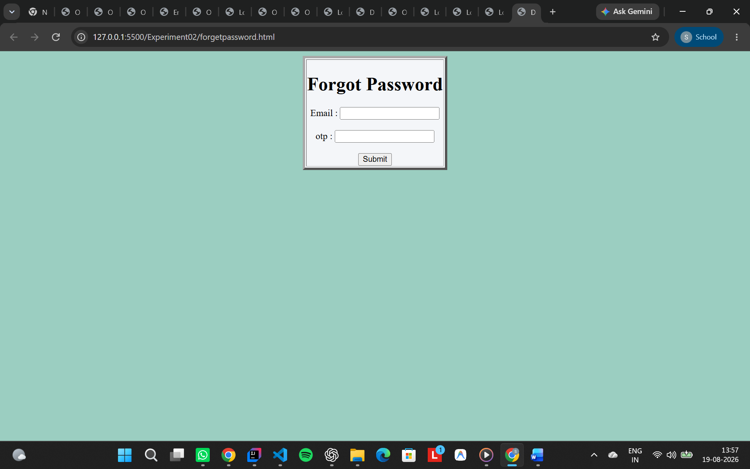

Final Output :-

